TASK LEVEL (INTERMEDIATE):
ANALYSIS OF THE AIR QUALITY INDEX (AQI) IN DELHI
Name: A. Tarini
Domain: Data Science
Shadow-Fox Virtual Internship Program

Objective
The objective of this project is to analyze Delhi's air quality data using Microsoft Excel and identify key pollution patterns, seasonal variations, statistical insights, and the impact of geographical factors on air quality.
Data Preparation
The dataset was imported into Excel and processed for analysis. Additional columns such as Year, Month, Hour, and Season were created to enable time-based analysis. The data was reviewed and organized for further statistical evaluation and visualization.
Statistical Analysis
Descriptive statistical measures were calculated for the major pollutants present in the dataset. These measures included:
- Average (Mean)
- Minimum Value
- Maximum Value
- Standard Deviation

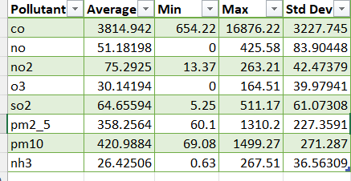

The statistical analysis helped in understanding the overall distribution and variability of pollutant concentrations across the observed period.
Seasonal Analysis
The data was categorized into different seasons to examine changes in pollution levels throughout the year. The analysis indicated that pollutant concentrations generally increase during winter due to unfavorable atmospheric conditions and decrease during the monsoon season because rainfall helps remove pollutants from the air.
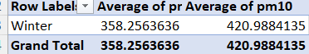

Pollutant Analysis
Major pollutants such as PM2.5, PM10, NO₂, SO₂, CO, and O₃ were analyzed. Particulate matter pollutants, especially PM2.5 and PM10, were found to have a significant influence on overall air quality and showed noticeable seasonal fluctuations.

Pivot Table Analysis
Pivot Tables were used to summarize pollutant data across different time periods and categories. This allowed efficient comparison of pollution levels by season, month, and year while identifying important trends and patterns.

Data Visualization
Several charts and visualizations were created to represent pollutant trends and seasonal variations. These visualizations improved the interpretation of the dataset and helped identify periods of high and low pollution.
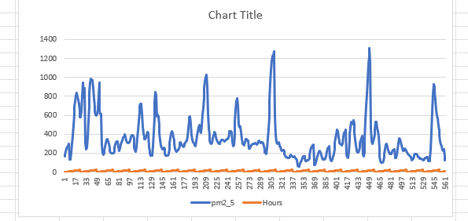
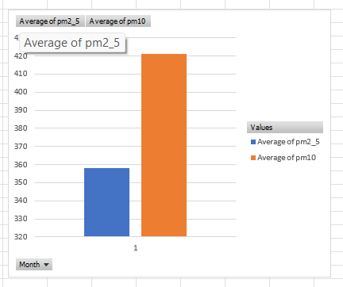

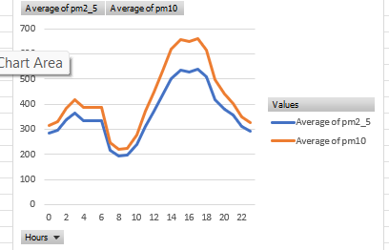

Geographical Factors Affecting Air Quality

Delhi's geographical location contributes significantly to its air quality conditions. The city is located in the Indo-Gangetic Plain, where pollutants tend to accumulate due to limited air circulation. During winter, temperature inversion traps pollutants near the ground, leading to increased pollution levels. Low wind speeds, dust transported from nearby regions, and high urban population density further contribute to poor air quality. These geographical and meteorological factors play a major role in determining pollution patterns throughout the year.

Conclusion
The analysis successfully identified important pollution trends and seasonal variations in Delhi's air quality data. Statistical analysis, Pivot Tables, and visualizations provided meaningful insights into pollutant behavior. The findings indicate that particulate matter pollutants are major contributors to air pollution and that seasonal and geographical factors significantly influence air quality levels. The results of this study can support environmental monitoring and informed decision-making for pollution control strategies.

